
Timberland Football Boosters – 2026 Sponsorship Levels
We are looking to raise $25,000 for Timberland High School Football. We can’t meet our goal without the help of companies like yours.

By giving to the Timberland Football Boosters, you’ll be helping us provide:
- New uniforms
- Weight room equipment
- Team meal before each varsity game
- Funding for student/athlete scholarship

These are some ways that you can help:
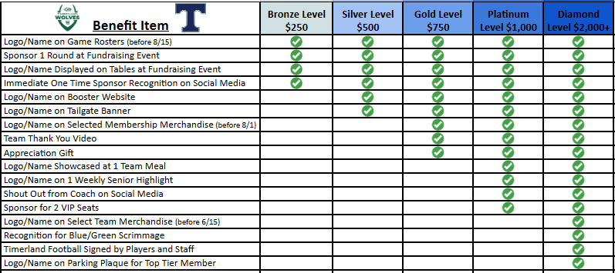

Gift Cards/Gift Baskets for Glow Bingo Night (08/29)
Contact Tiffany Barfield at 314-683-7500 or timberlandfbevents@gmail.com
(Food dollar amount donations for Feed the Pack before games will match Tier level)
Payment Info:
- Venmo: @Timberland-Football-Boosters
- PayPal: timberlandfootballhc@gmail.com
- Check: Timberland Football Boosters
- All donations are tax deductible
- Treasurer will mail receipt after payment is received.

We appreciate your time and consideration! For questions, please contact:
Laura Herbers 636-866-6335 or timberlandfootballhc@gmail.com

Sincerely,

Timberland Football Boosters Committee
Tax ID: 45-1583154

